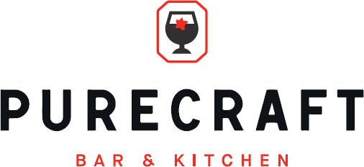

Sunday Specials Menu

**Chargrilled Bavette of Beef**

**£25**

**Chestnut Mushroom, Red Pepper and Hazelnut Roast (V)**

**£16.5**

**Garlic and Thyme Marinated Pork Chop**

**£18**

All served with

Crispy potatoes, honey glazed carrots, spring cabbage,

Purity ale gravy & cauliflower cheese.

